**11-2 Logarithms**

“6th log” like “6th root”. Each solves base to exponent = something. Why not the same (Compare, commutative property)

Student errors with properties, solving equations.

Graph transformations.

Fold to moon- halfway?

**Flipped Math 7.2**

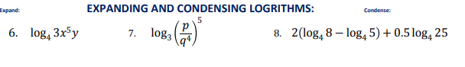

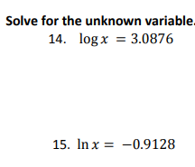

**(N- Solve for base in equation?)**

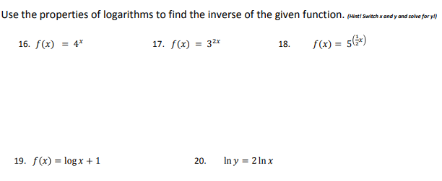

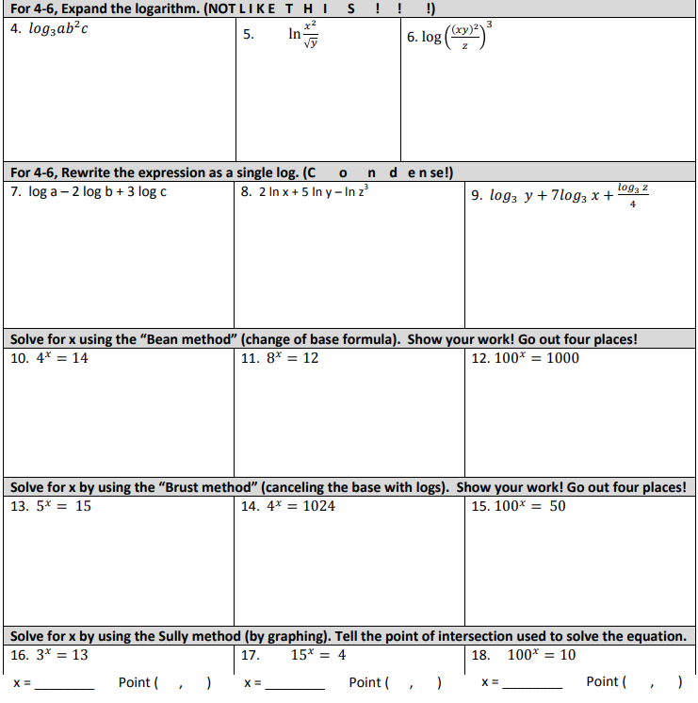

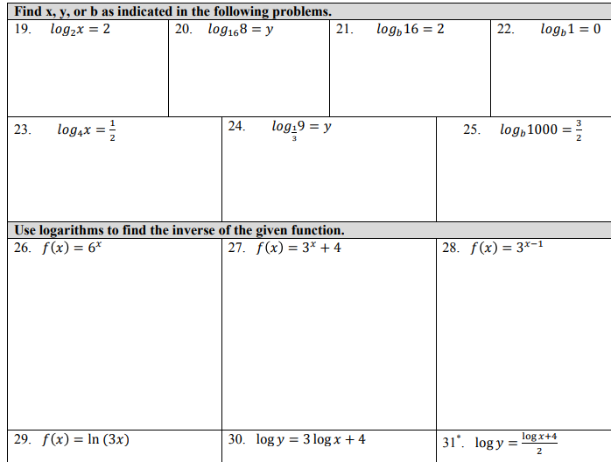

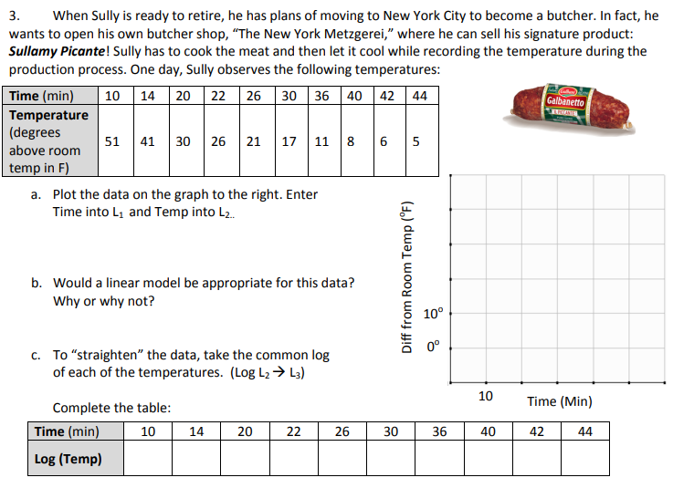

**FM 7.3:**

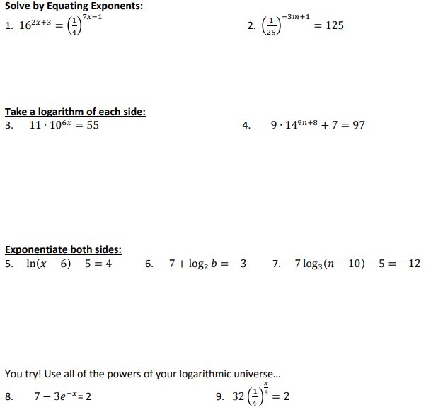

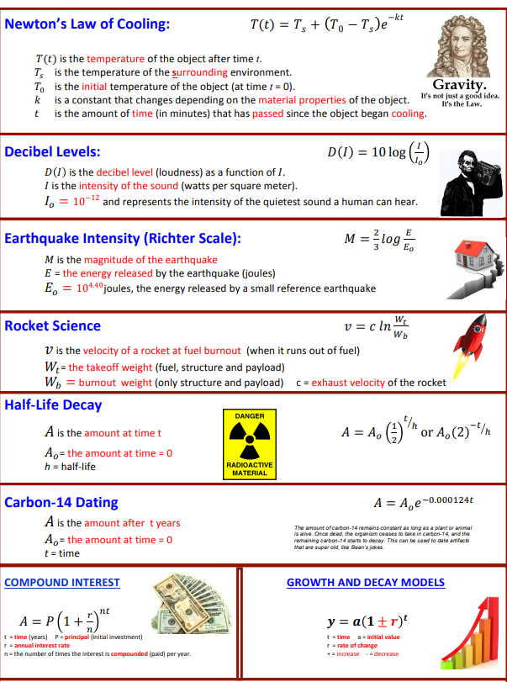

**N- Find half-life or “37% life”**

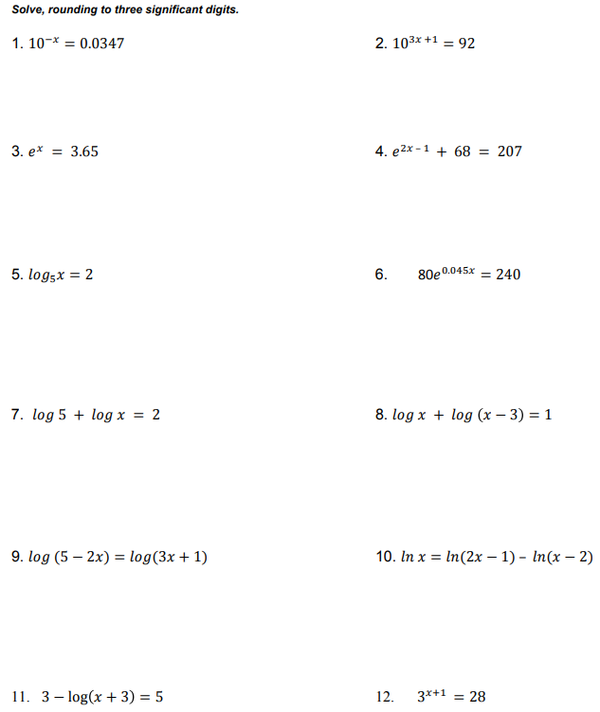

**(N-solve exactly?)**

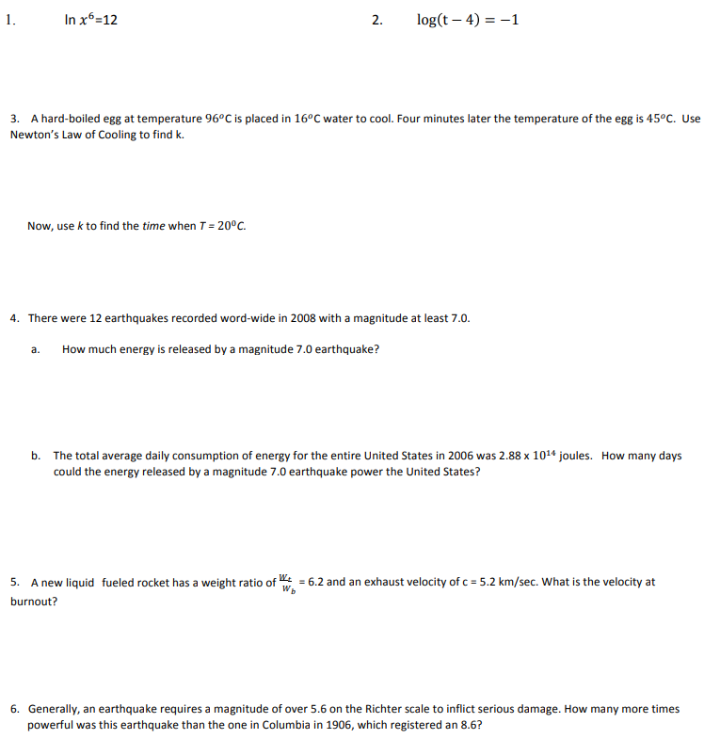

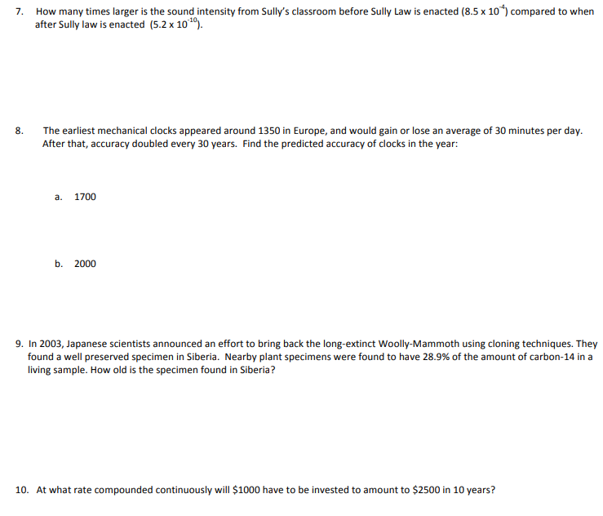

**S-Z 6.1 p. 430**

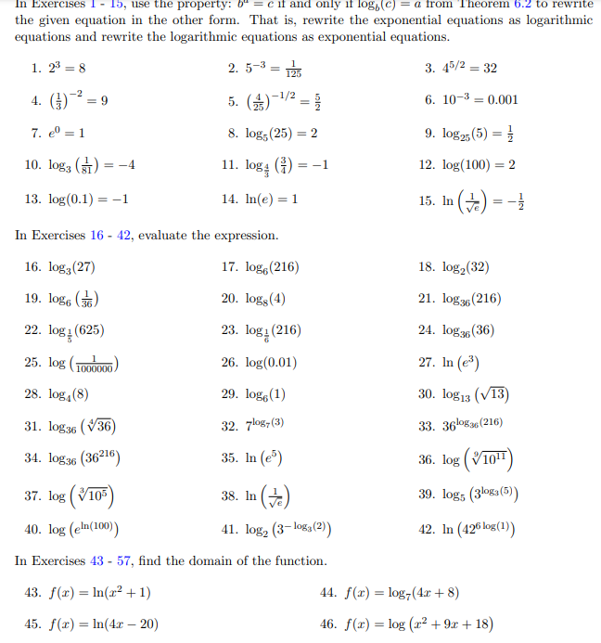

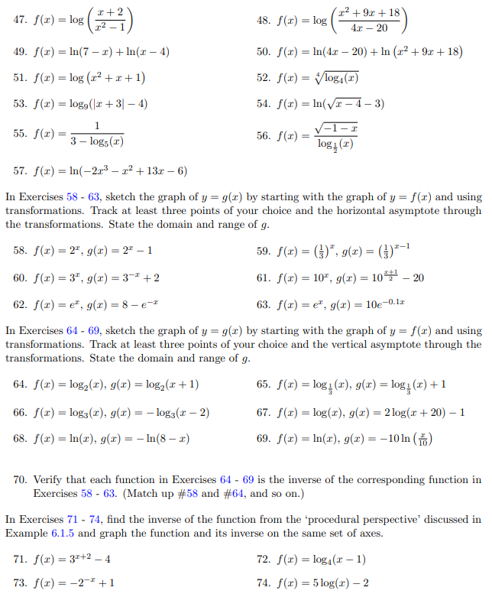

**S-Z 6.2 p. 445**

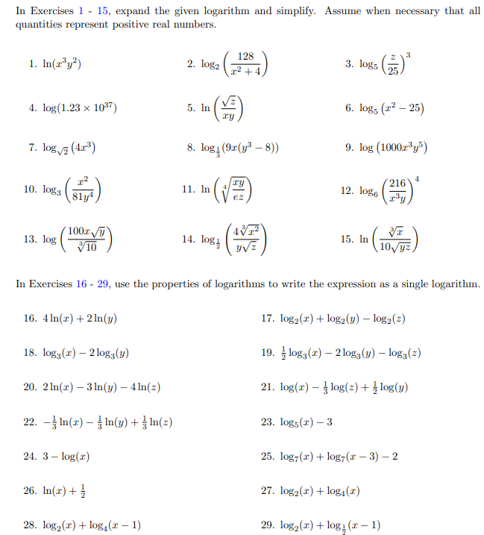

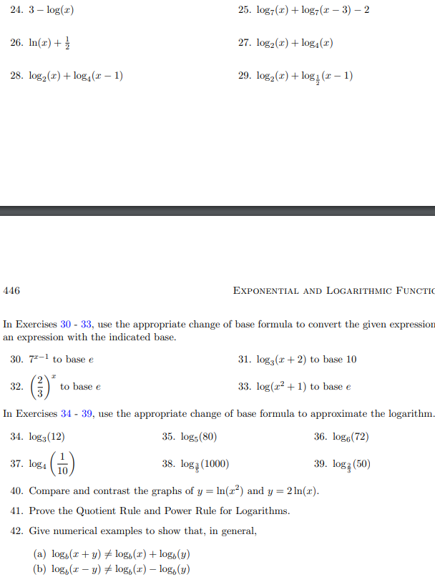

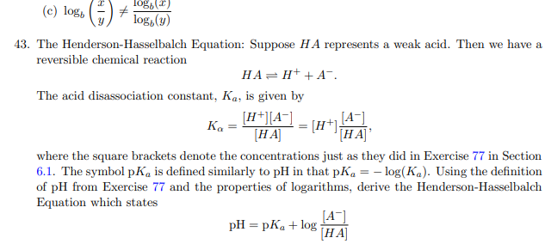

**S-Z 6.4 (6.3 = exponential eqns and inequalities)**

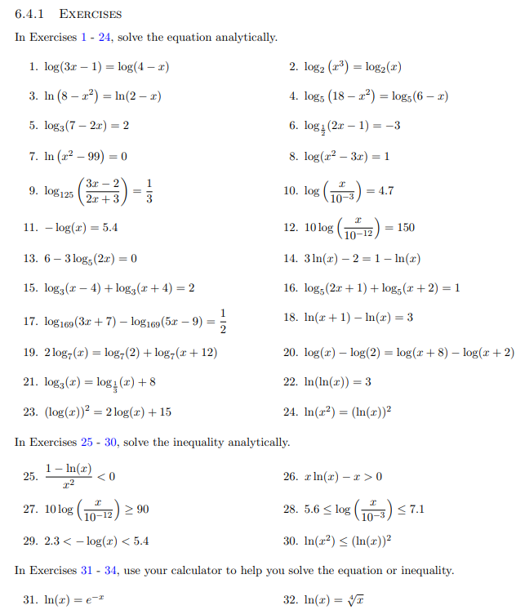

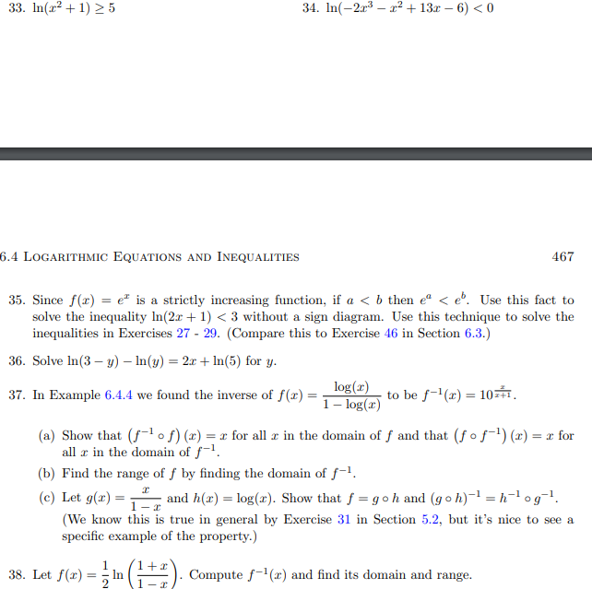

**S-Z 6.5**

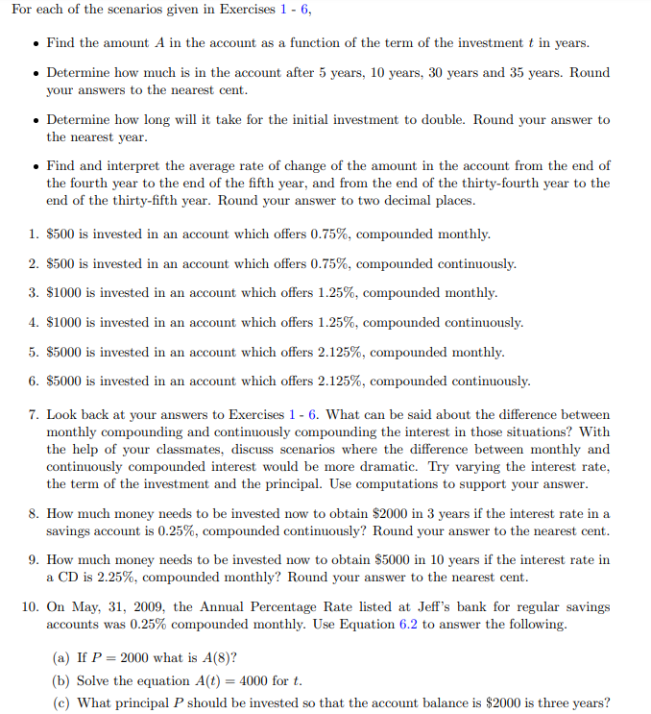

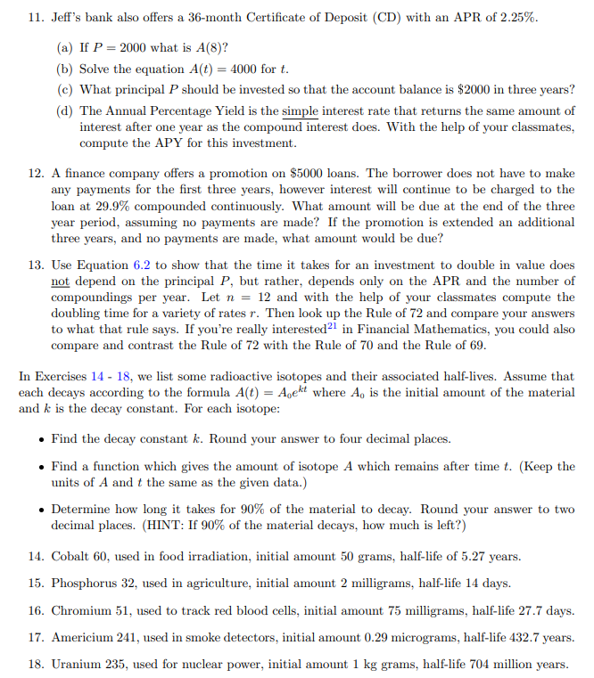

**N- Annuity formula?**

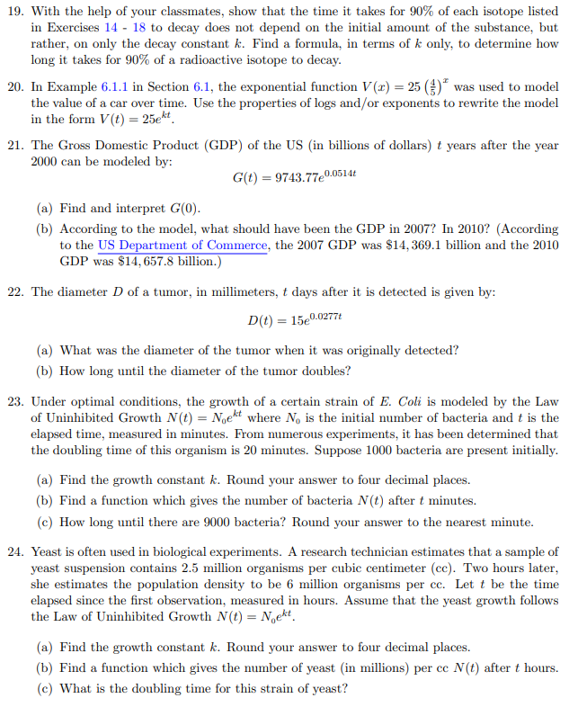

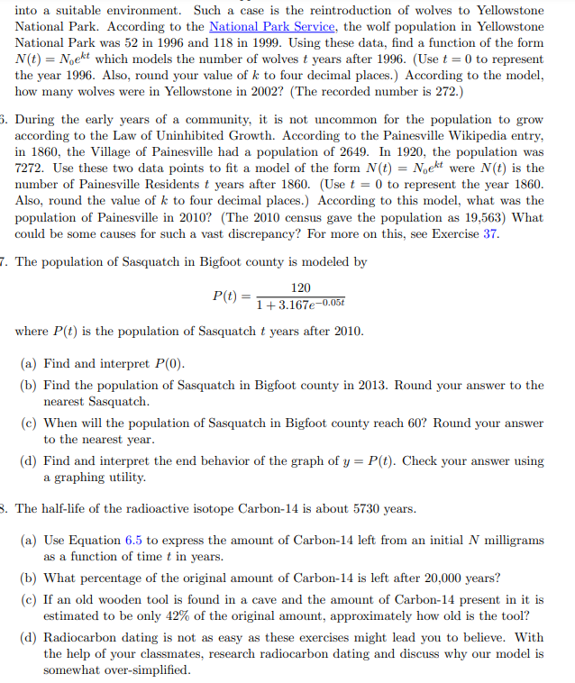

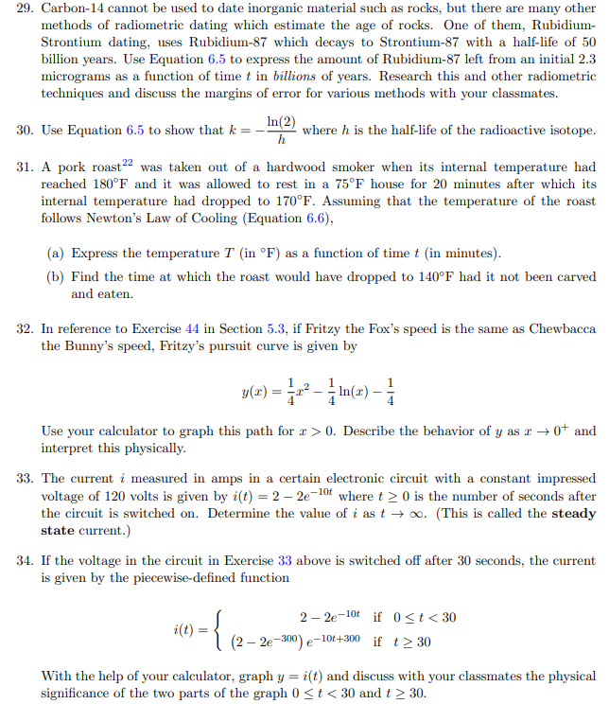

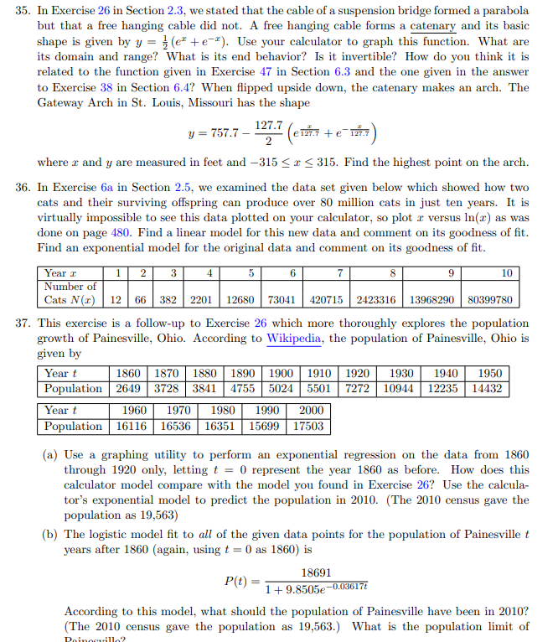

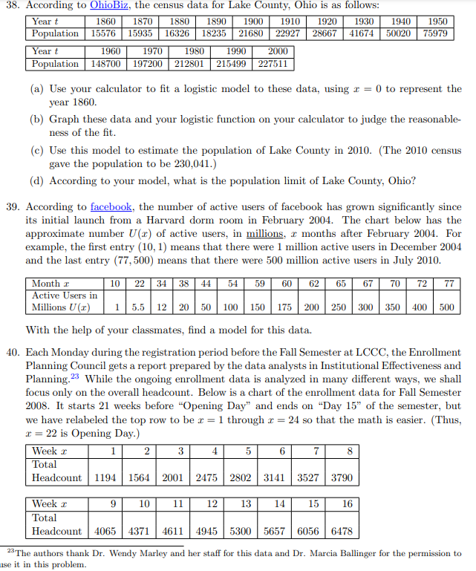

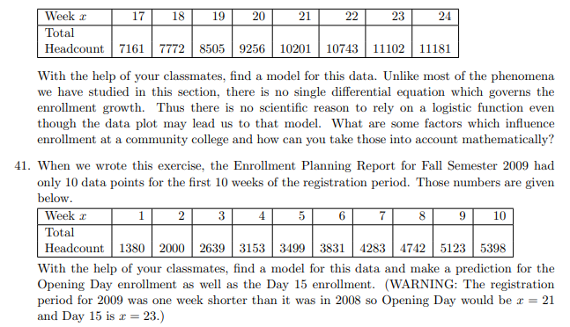

**Active Reading 4.1**

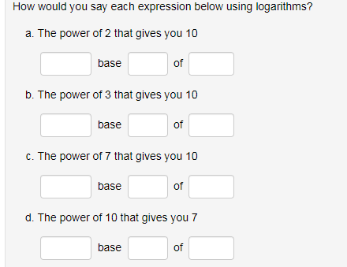

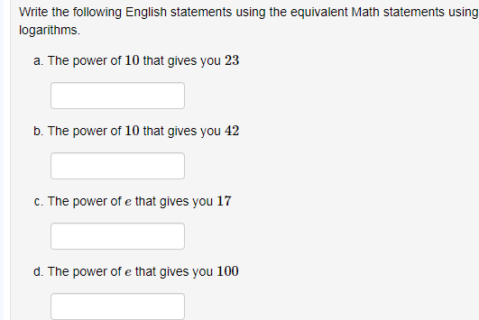

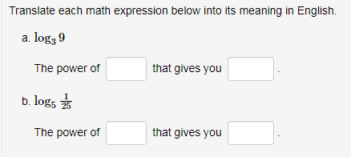

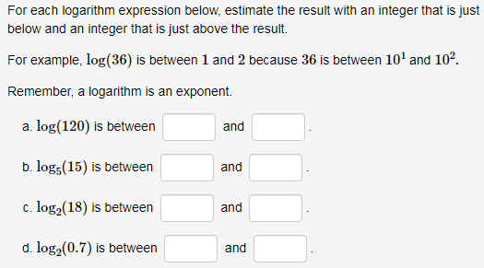

**Active Reading 4.2**

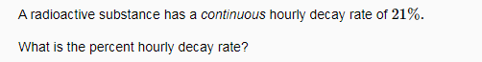



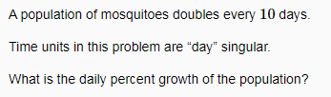

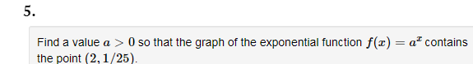

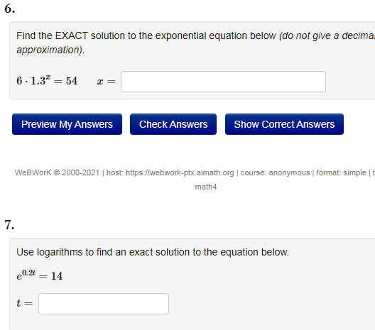

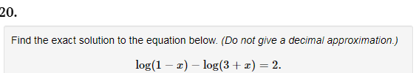

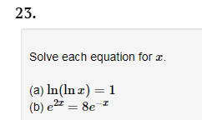

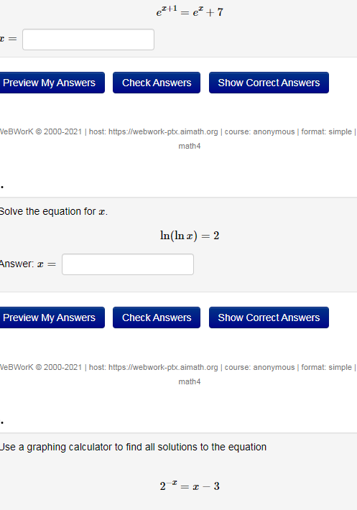

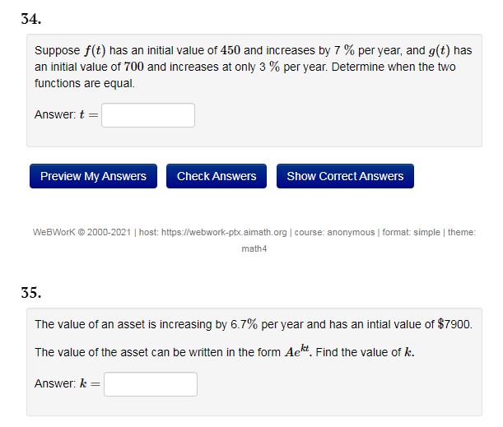

**APC 3.4**

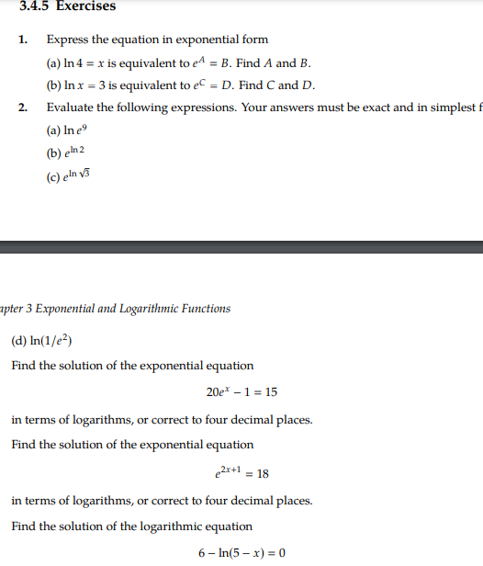

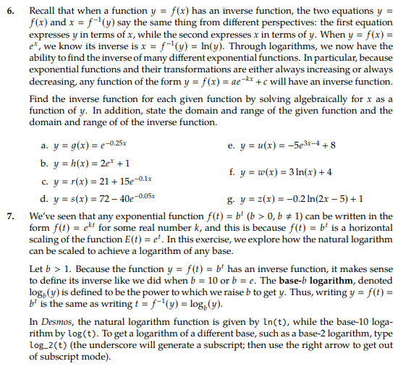

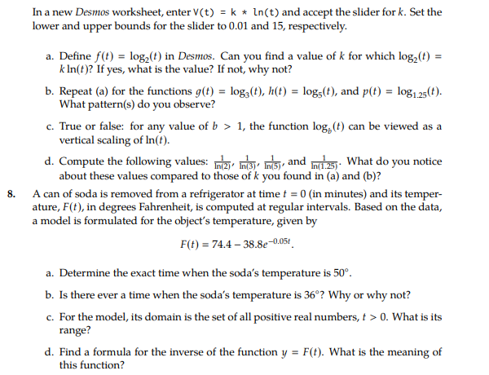

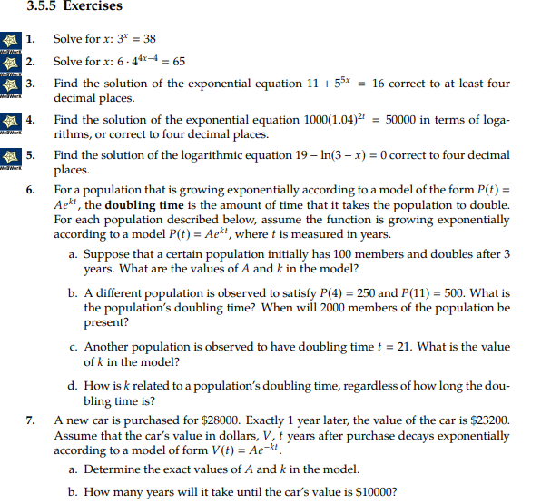

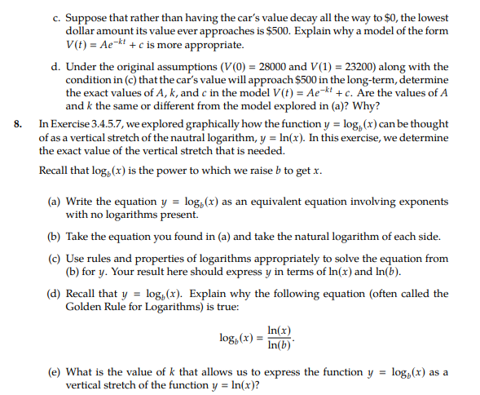

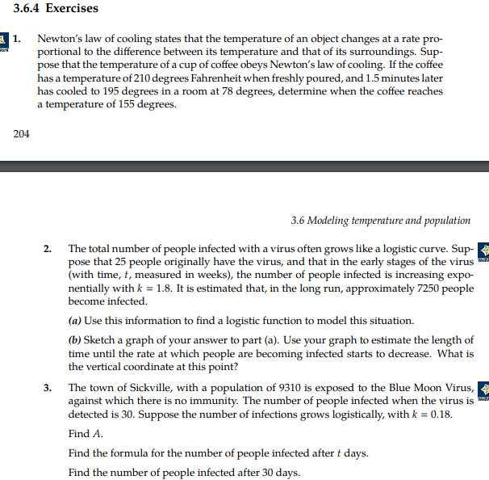

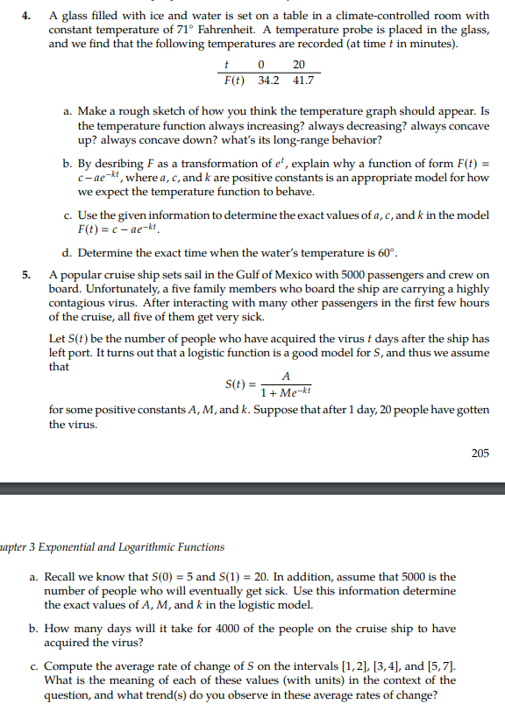

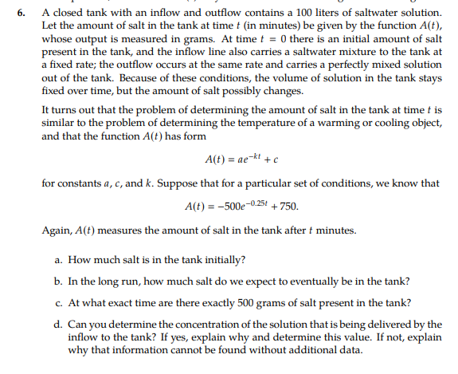

**Calc Medic**

1. Complete the following table using your calculator.

2. Using the patterns you see in the table, complete the equation below.

3. How could we find the value of $\log{30}$ if the “3” button is missing on our calculator?

Round answers to four decimal places.

|  |  |
| --- | --- |
|  |  |
|  |  |
|  |  |
|  |  |
|  |  |
|  |  |

5. Using the patterns you see in the table, complete the equation below.

6. How could we find the value of $\log{30}$ if the “3” button is missing on our calculator?

1. Complete the following table using your calculator.

Round answers to four decimal places.

|  |  |
| --- | --- |
| $$\log{5}$$ |  |
| $$\log{10-\log{2}}$$ |  |
| $$\log{7}$$ |  |
| $$\log{28}-\log{4}$$ |  |
| $$\log{\frac{1}{2}}$$ |  |
| $$\log{3-\log{6}}$$ |  |

1. A student noticed that $\log{\frac{1}{2}}$ gave the same result as $-\log{2}$. How is this possible?
2. Saul was practicing evaluating logarithms on his calculator on Halloween. After he had finished all the calculations he was startled at the results. He was sure that a ghost has haunted his calculator and broken it. What do you think? Can you make sense of the results? Is his calculator haunted?

|  |  |
| --- | --- |
| $$\log{5}+\log{5=1.398}$$ | $$\log{4}+\log{4+\log{4}=1.806}$$ |
| $$2\log{5=1.398}$$ | $$3\log{4}=1.806$$ |
| $${\log{5}}^{2}=1.398$$ | $${\log{4}}^{3}=1.806$$ |
| $$\log{25=1.398}$$ | $$\log{64=1.806}$$ |
| $$\frac{1}{2}\log{625=1.398}$$ | $$\log{2^{6}}=1.806$$ |

1. Write two more log statements that are also equal to 1.806.
2. Dextromethorphan has a half-life of 3 hours. This means that every 3 hours, your body will eliminate ½ of the current amount. In a 30 mL dosage of liquid DayQuil™, there are 20 milligrams of Dextromethorphan, and after 3 hours, 10 mg would still be in your system.
   1. How many mg of the drug will be in your system after 6 hours? After 9 hours?
   2. How many mg of the drug will be in your system after 10 hours? How do you know?
3. Write a formula, $D(t)$, that gives the amount of Dextromethorphan in your system after *t* hours.
4. What percent of the drug remains in your body after *1* hour? What percent is eliminated?
5. Customers are instructed to use the medicine “as directed”. For the average adult, Dextromethorphan is effective in quantities over 8 mg. What should the directions say about how often an adult should take the recommended serving?

* 1. What does the 30.92 represent? What does the 0.1171 represent?
  2. When will the number of U.S. households reach 100 million?

1. An investor invests $1000 into an account that has continuously compounded interest. If after 3 years he has $1,450, what is the interest rate of the account?
2. On the Great British Baking Show, a contestant takes their cake out of an 180˚ C oven and puts it in a refrigerator whose temperature is set at 3˚ C. After 10 minutes, the cake has cooled to 150˚C. The temperature of the cake, in ˚C, *t* minutes after it is removed from the oven can be modeled by the equation $C\left(t\right)=Ae^{kt}+3$.
3. Find the values of *A* and *k*.
4. What will be the temperature after 45 minutes?

**MFG 4.3**

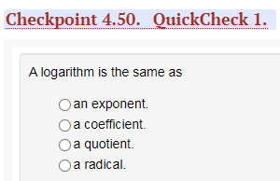

**MFG 5.1**

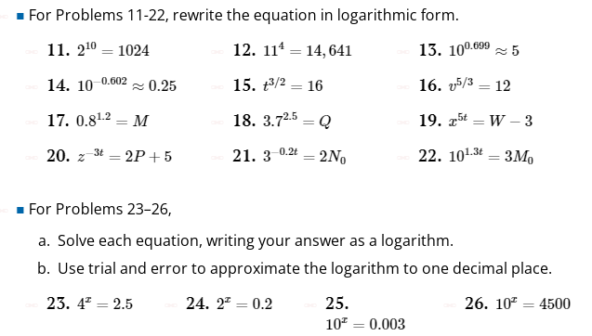

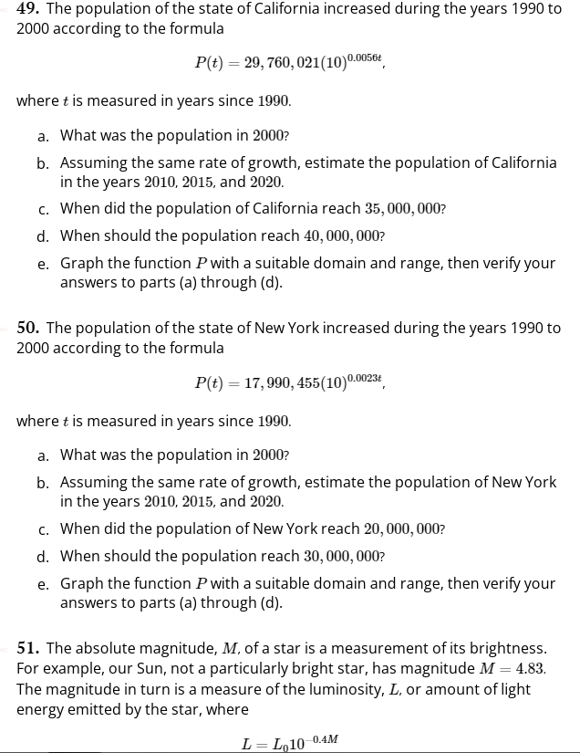

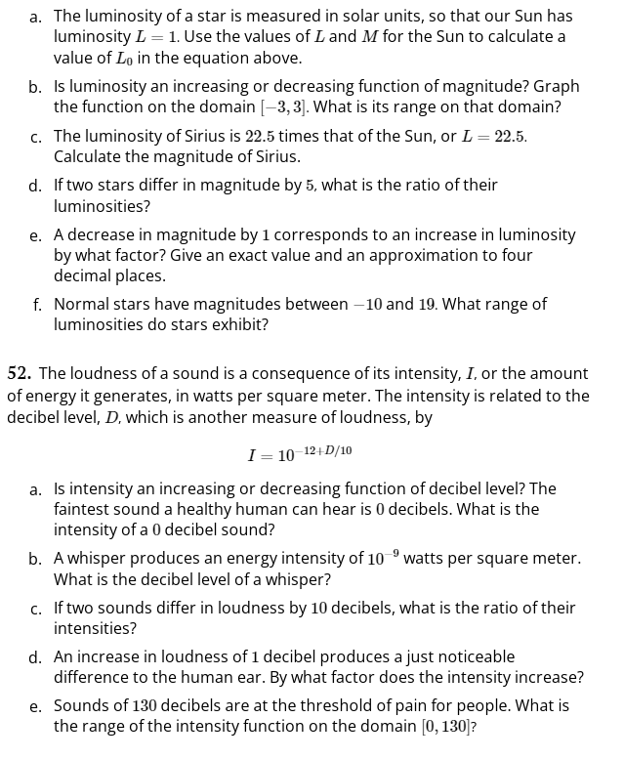

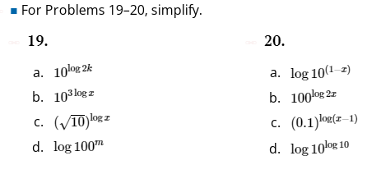

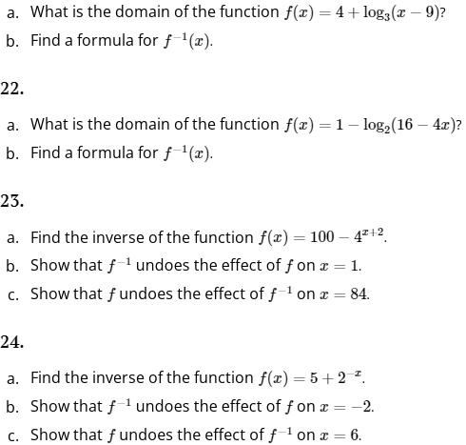

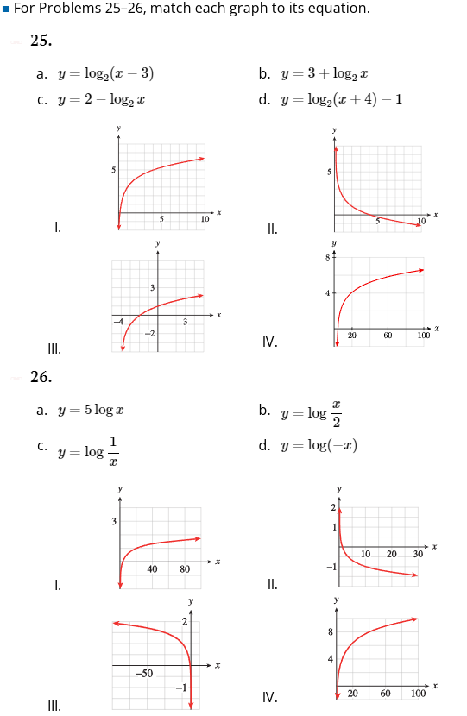

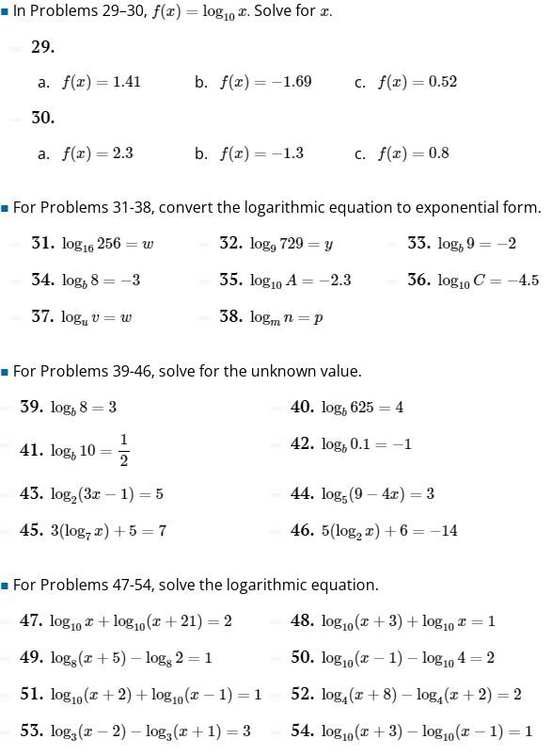

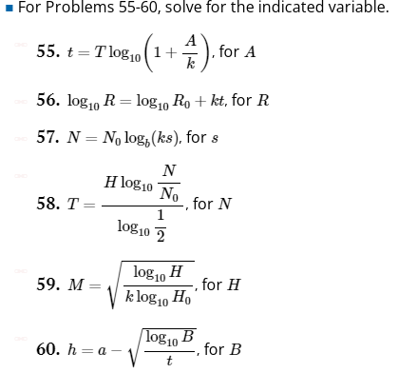

**MFG 4.4**

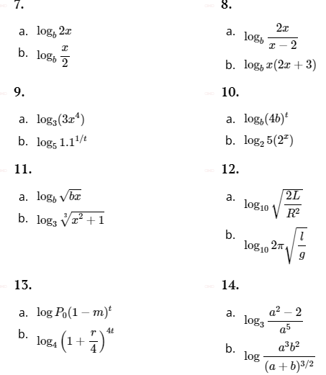

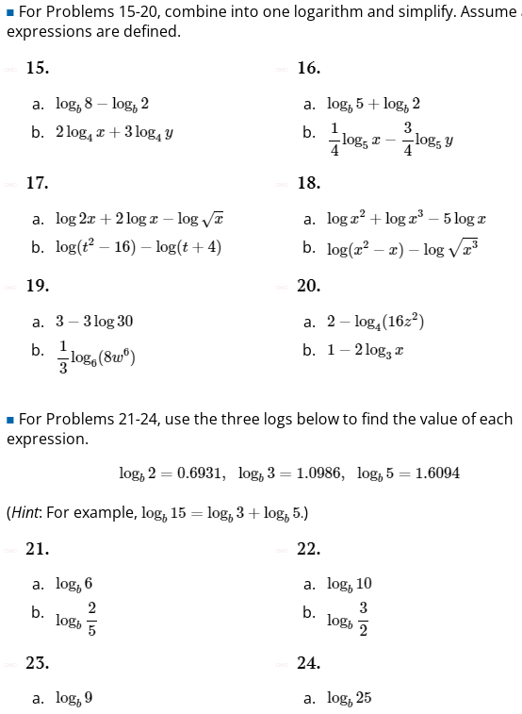

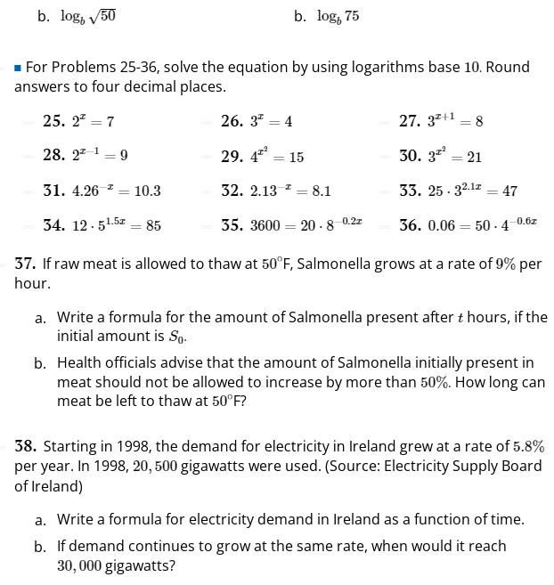

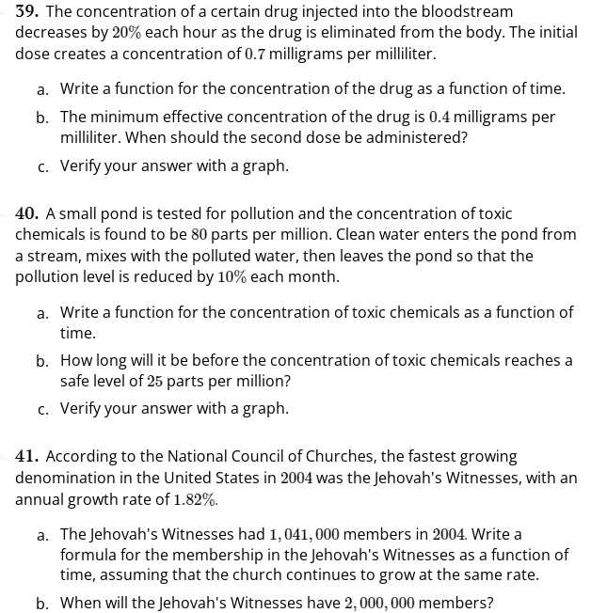

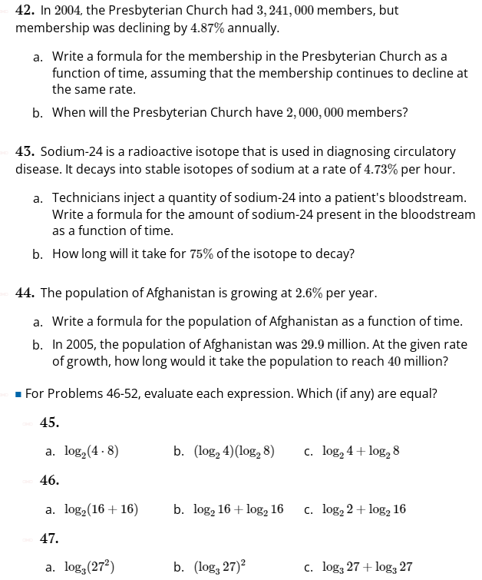

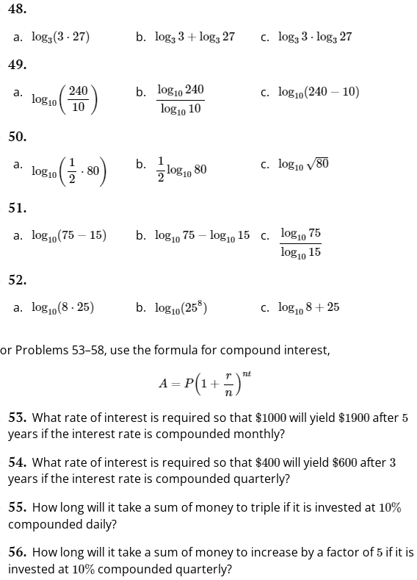

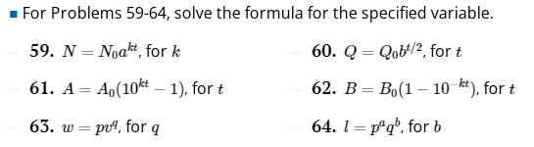

**MFg 4.5**

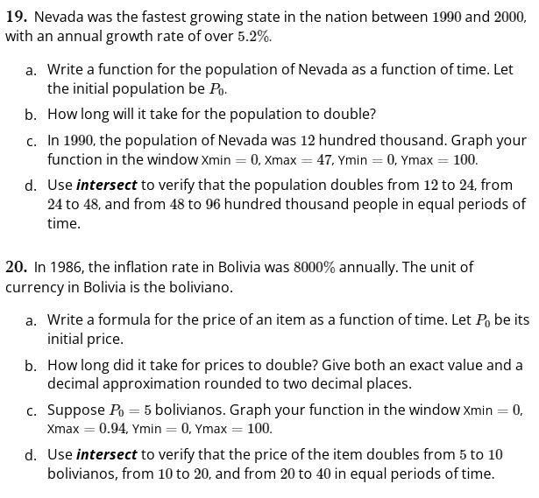

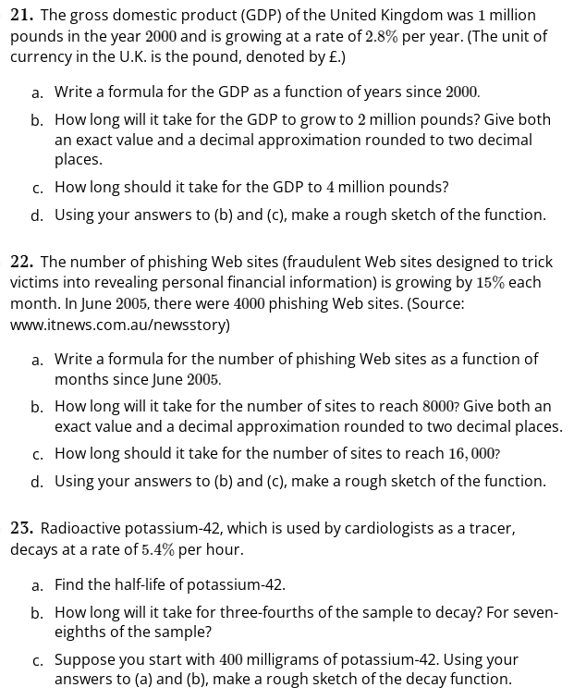

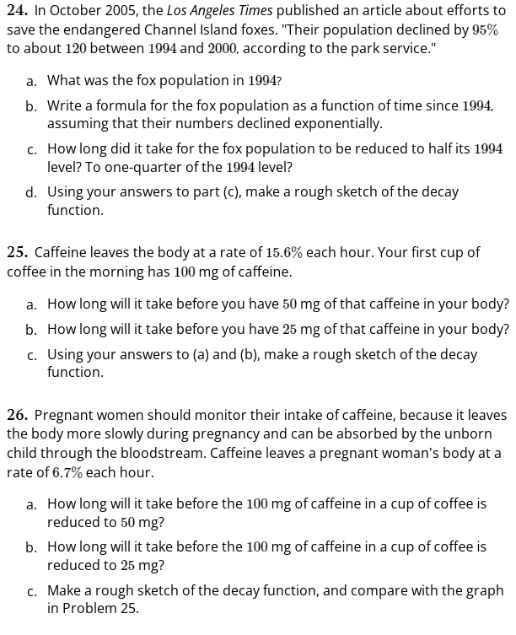

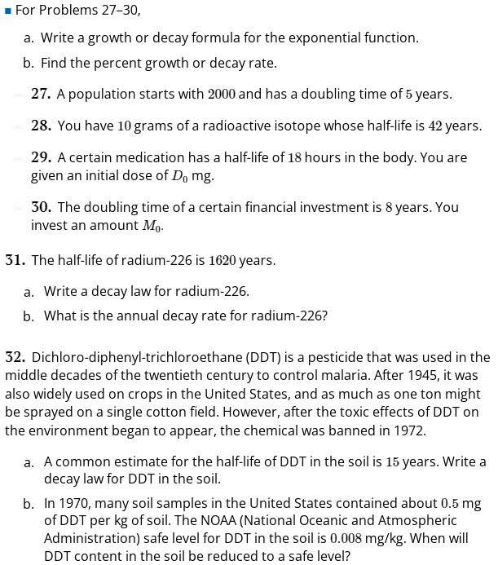

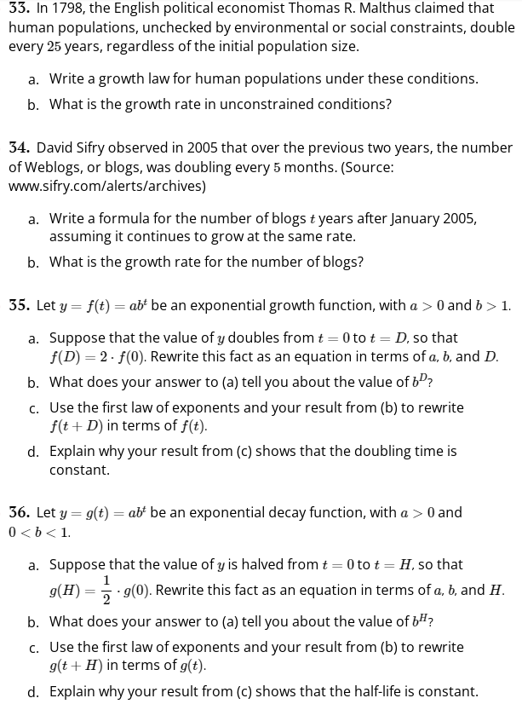

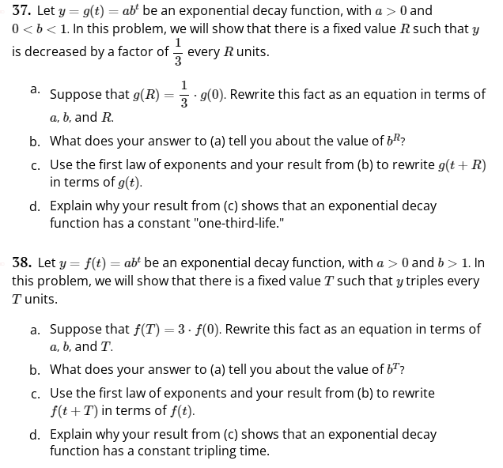

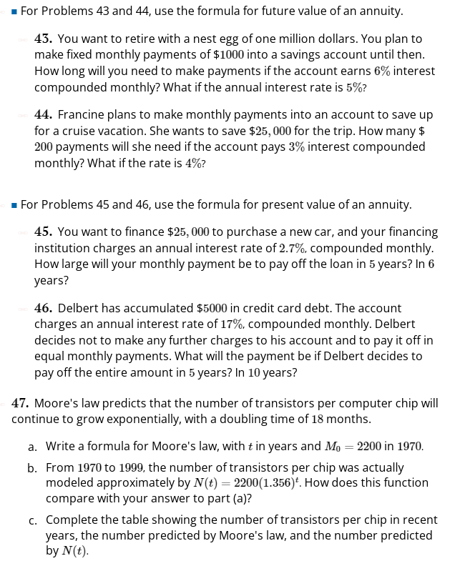

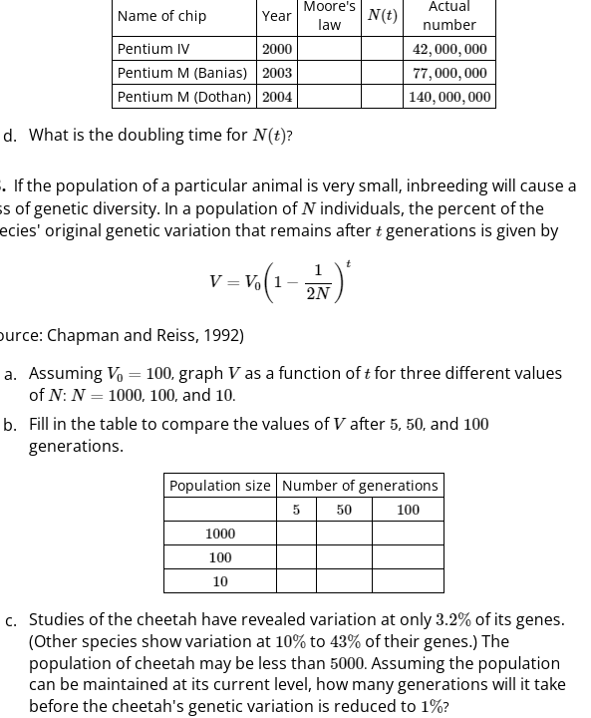

**MFG 4.6**

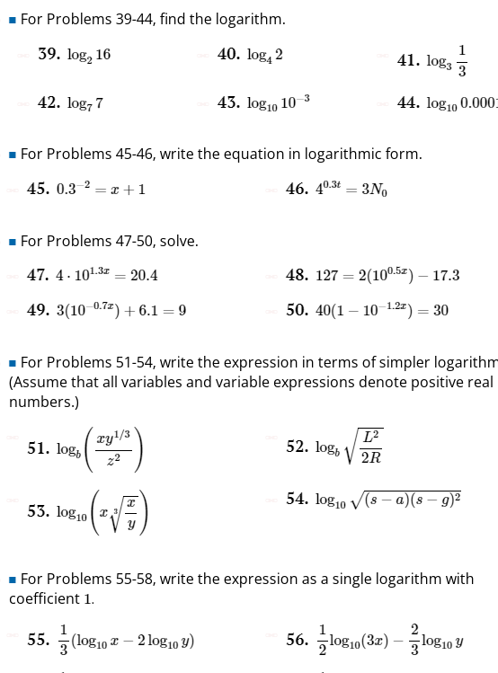

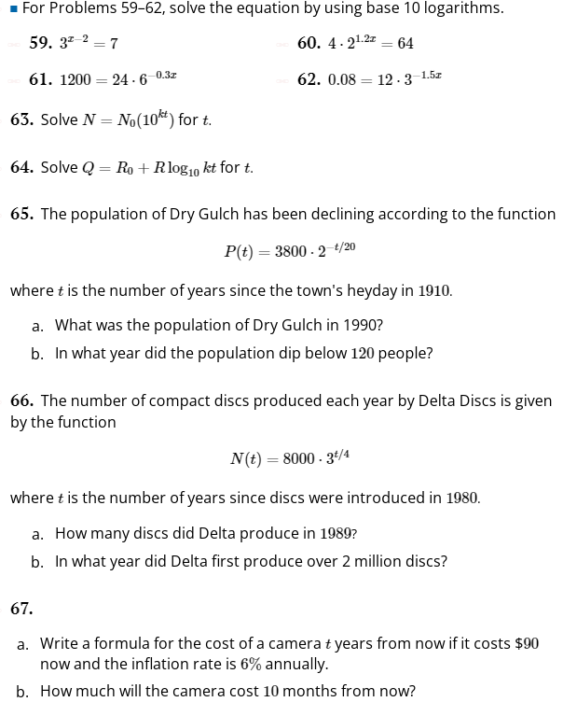

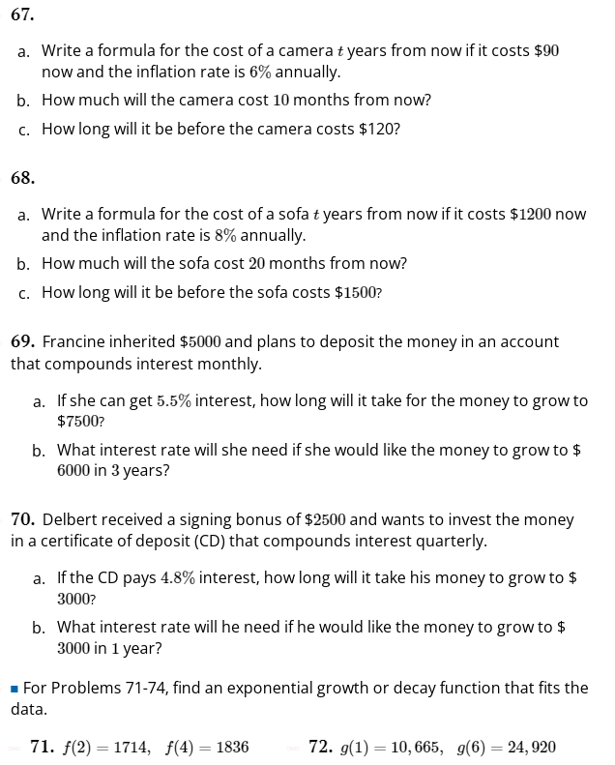

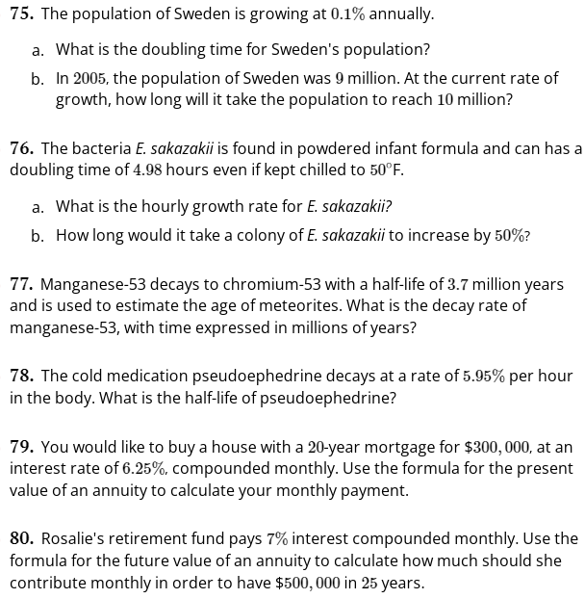

**MFG 5.3**

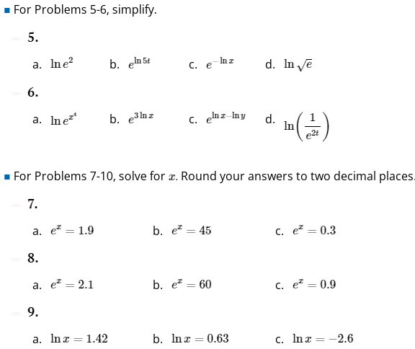

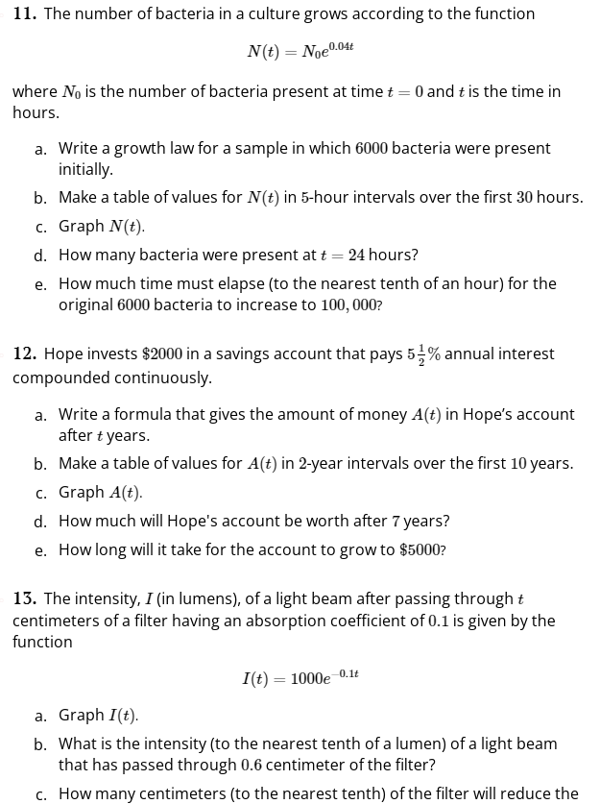

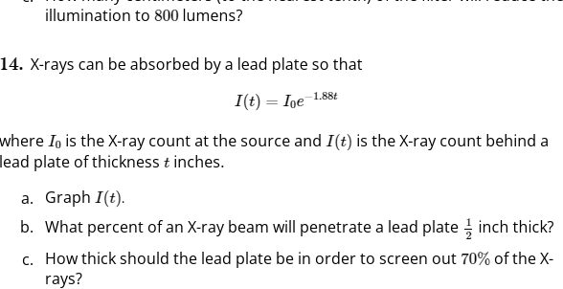

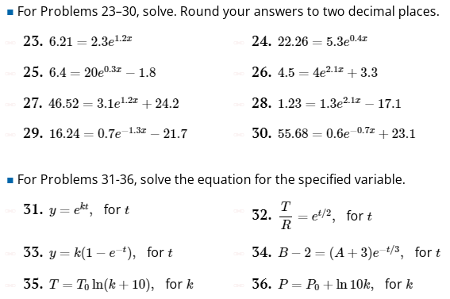

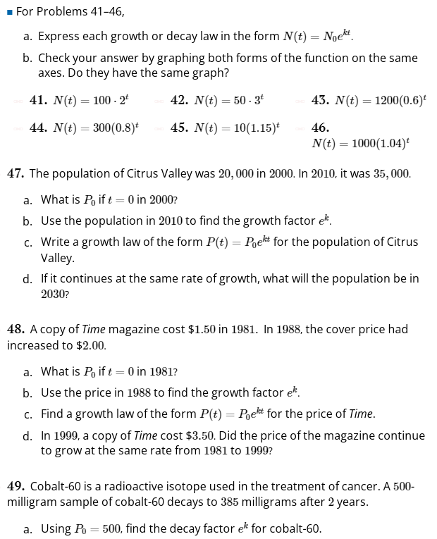

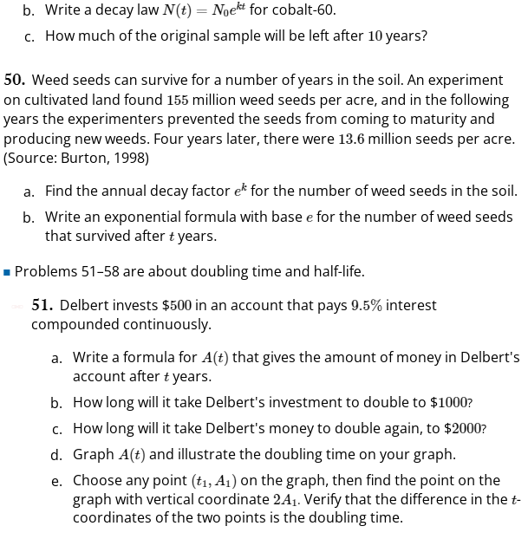

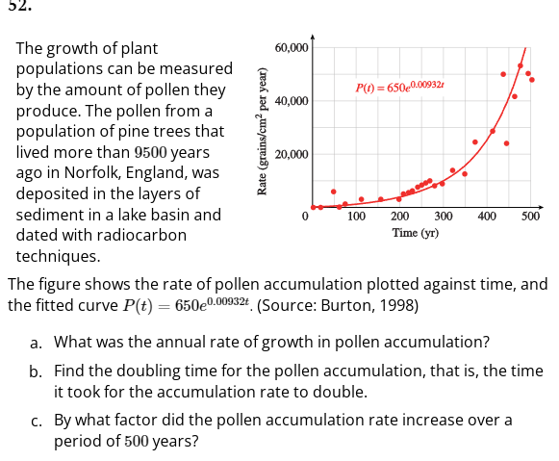

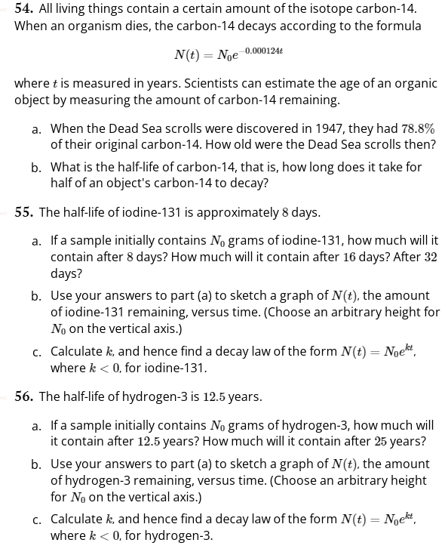

**MFG 5.4 (Log Scales: Do these? (Several more problems in 5.4. e.g.:**

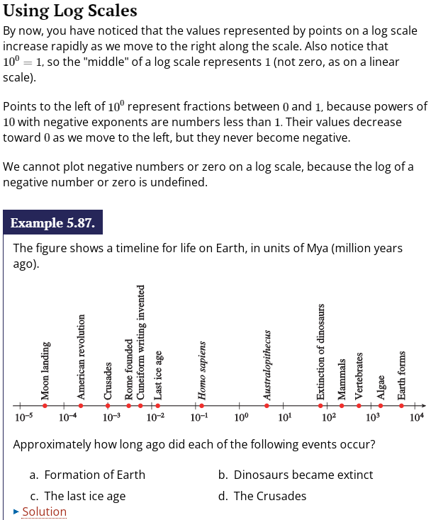

**MFg 5.5**

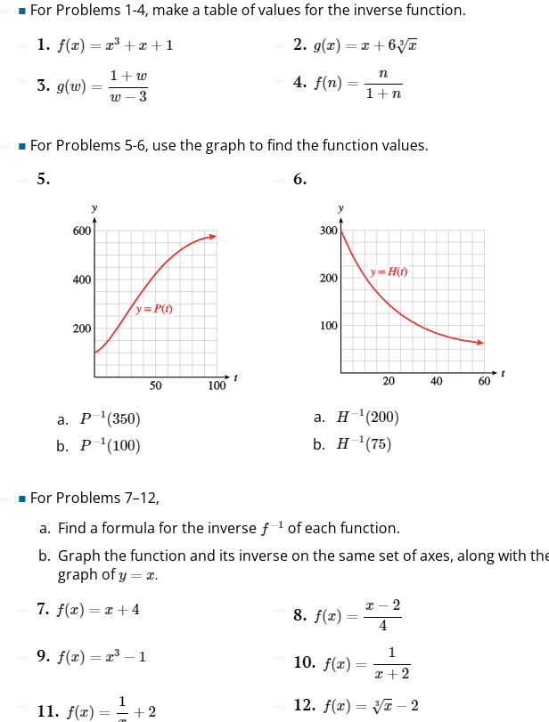

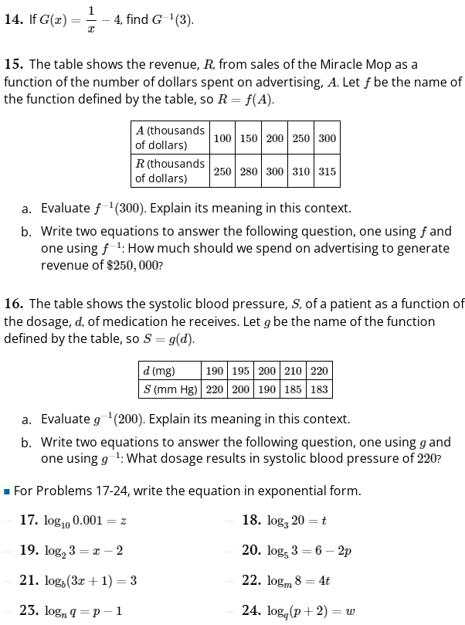

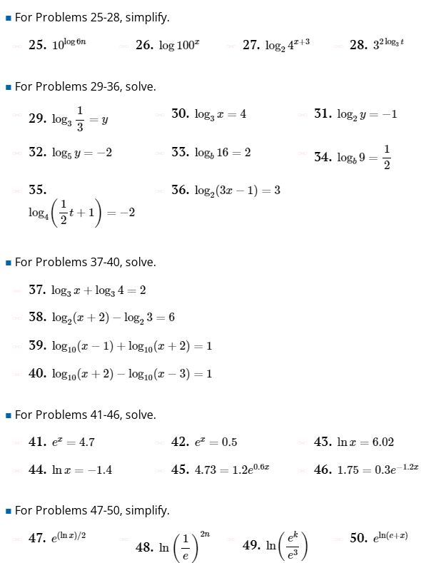

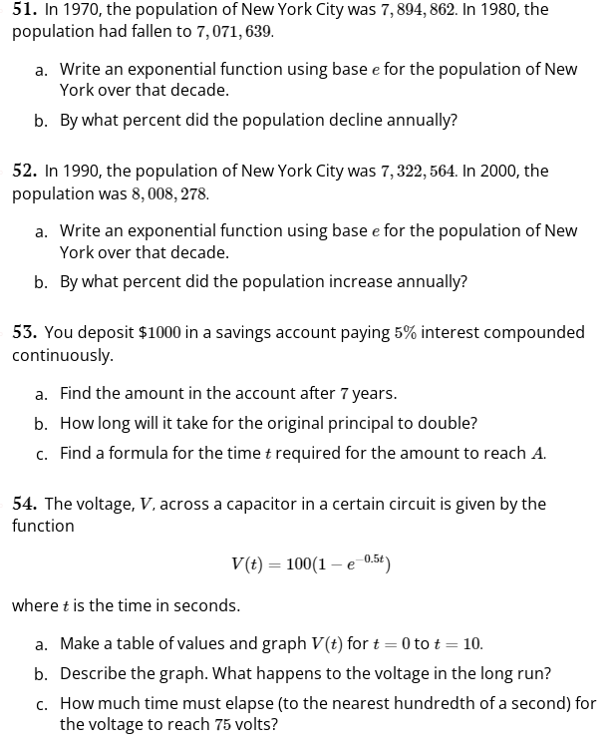

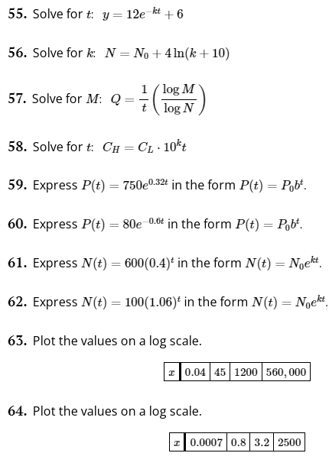

11-3 Inverse Trig